SIMATS ENGINEERING
ASSESSMENT TOOL 1 : Concept Mapping

COURSE NAME: Cloud Computing and COURSE CODE: CSA1518
Big Data Analytics

COURSE OUTCOME COVERED
CO1: Apply cloud computing technologies including hardware-software evolution, virtualization, web services, and service models to develop cloud-based solutions. (BL2)
Assessment Tool Weightage: 20%

Dave's Taxonomy: Imitation (Level 1) Total Marks: 50
Question Count: 4

Code of Conduct
I Raja.Vishnu Vardhan (192521316) certify that this submission is my original work and that I have adhered to the guidelines specified for this assessment.
I understand that any violation of academic integrity rules will result in disciplinary action. Signature of the student: RAJA. VISHNUVARDHAN

Assessment Tasks Concept Mapping Tasks
Create concept maps for the following tasks. Each map must show key nodes, link labels, and a logical hierarchy.
- Concept Map 1: Cloud Computing Fundamentals. Include definition, characteristics, benefits, and limitations.
- Concept Map 2: Evolution of Cloud Computing. Connect hardware evolution, internet software evolution, distributed systems, and service delivery.
- Concept Map 3: Service Models. Map IaaS, PaaS, SaaS, and XaaS with provider responsibilities and user responsibilities.
- Concept Map 4: Virtualization and Web Services as Enablers of Cloud. Show how these two concepts support cloud deployment and scalability.
Expected concept nodes:
- Elasticity, scalability, resource pooling, on-demand access, measured service
- Virtual machine, hypervisor, abstraction, API, SOAP, REST, provider, consumer
- Infrastructure layer, platform layer, application layer, shared responsibility

Concept Mapping Rubric
Criteria | Weightage | Level 4 -  Exemplary | Level 3 -  Proficient | Level 2 -  Developing | Level 1 -  Beginning
Concept  Identification | 25% | All major concepts are accurately identified | Most concepts are identified correctly | Limited concepts are identified | Essential concepts are missing
Relationship  Mapping | 25% | Links between concepts are | Most links are correct | Some links are weak or unclear | Relationships are mostly incorrect
 |  | accurate and meaningful
Hierarchy and Organization | 20% | Excellent structure with clear hierarchy | Mostly organized with minor issues | Basic structure with weak hierarchy | No logical organization
Technical Relevance | 20% | Map strongly reflects cloud course content | Mostly aligned to topic | Partially aligned to topic | Weak alignment to topic
Visual Clarity | 10% | Neat, readable, and easy to interpret | Generally readable | Somewhat  cluttered | Poorly presented

Concept Map 1
Cloud Computing Fundamentals. Include definition, characteristics, benefits, and limitati
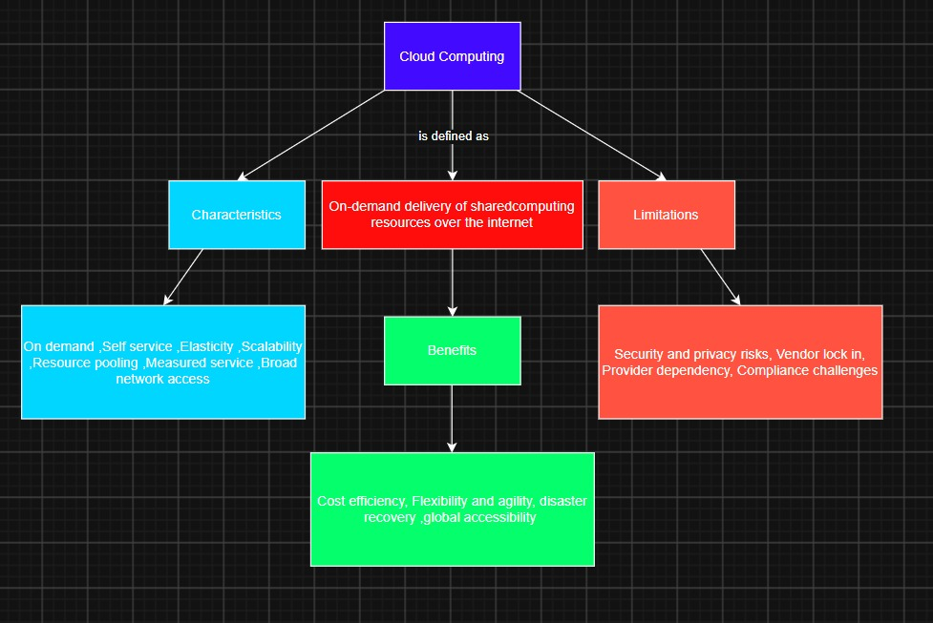

Concept Map 2
Evolution of Cloud Computing. Connect hardware evolution, internet software evolution, distributed systems, and service delivery.
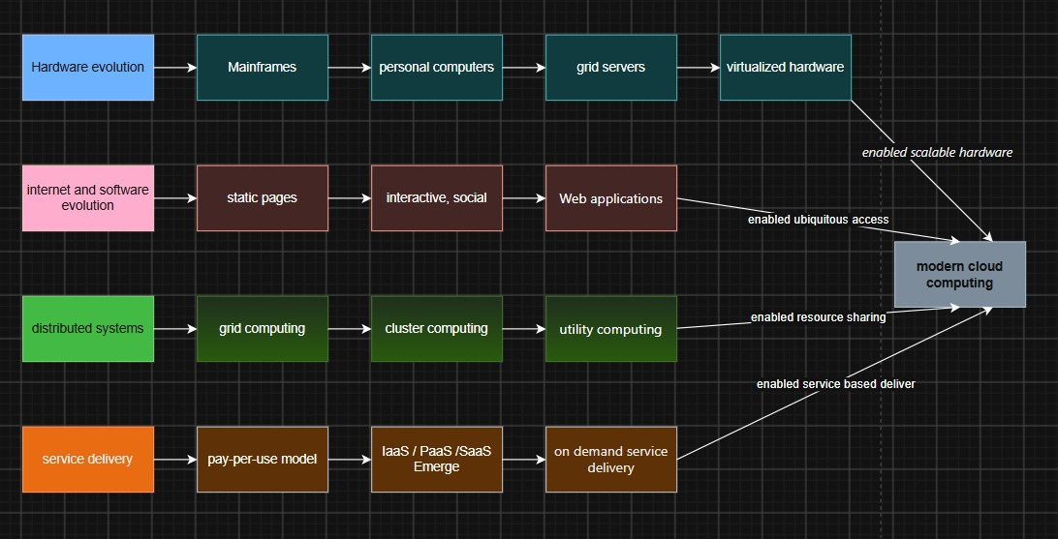

Concept Map 3
Service Models. Map IaaS, PaaS, SaaS, and XaaS with provider responsibilities and user responsibilities. 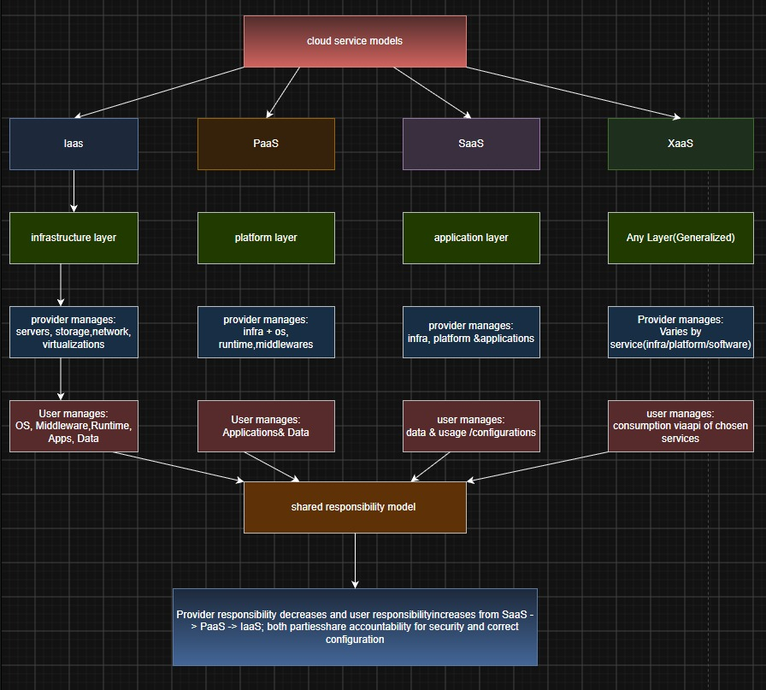
Concept Map 4
Virtualization and Web Services as Enablers of Cloud. Show how these two concepts support cloud deployment and scalability.
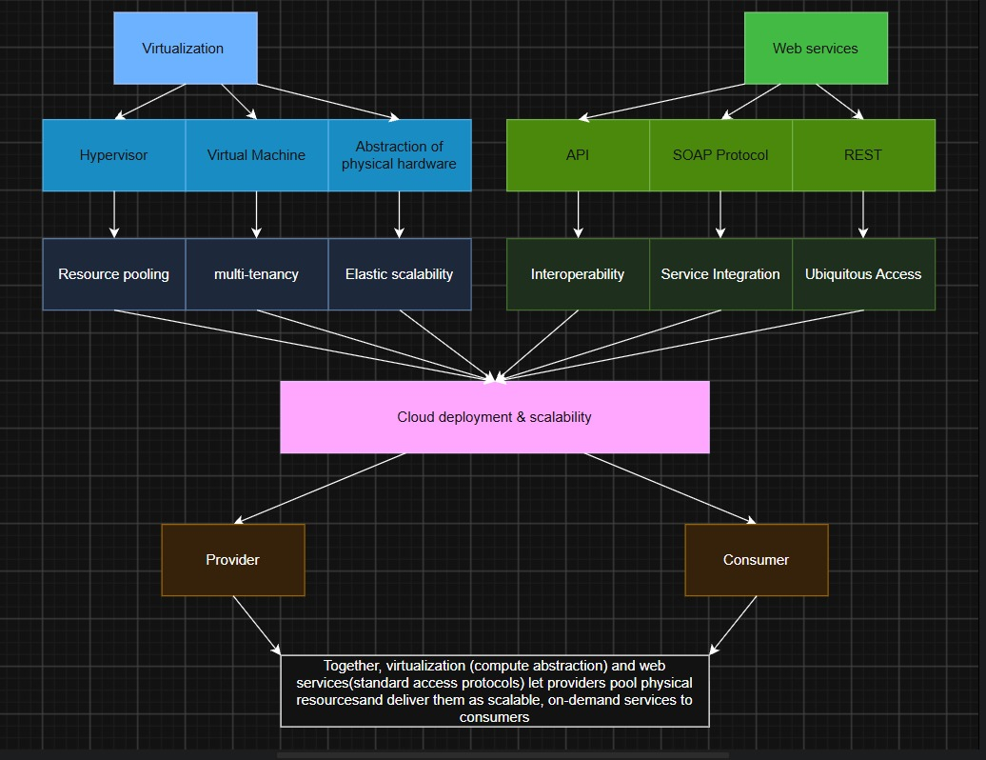
1. Evaluate the effectiveness of your concept map in representing cloud computing principles. Which design decisions most strongly support your solution, and why?
Effectiveness
- Clearly represents the key principles of cloud computing.
- Organizes concepts from general to specific.
- Makes complex cloud concepts easier to understand.
- Shows the relationship between virtualization, web services, deployment models, and scalability.
Design Decisions
- Used Cloud Computing as the central concept.
- Connected related concepts using branches and arrows.
- Placed each concept in a separate box for clarity.
- Followed a hierarchical structure to improve readability and logical flow.
2. Analyze how scalability, elasticity, and resource management influence the architecture shown in your concept map. What challenges could arise if these capabilities were absent?
Scalability
- Supports increasing workloads.
- Improves application performance.
- Enables vertical and horizontal scaling.
Elasticity
- Automatically adds or removes resources based on demand.
- Reduces unnecessary resource usage.
- Maintains continuous service availability.
Resource Management
- Allocates computing, storage, and network resources efficiently.
- Optimizes resource utilization.
- Reduces operational costs.
Challenges Without These Features
- Reduced system performance.
- Increased infrastructure costs.
- Resource wastage.
- Higher risk of downtime.
- Difficulty handling large numbers of users.

3. Justify the selection of the APIs, web services, or cloud services included in your concept map. How do they contribute to the overall functionality and efficiency of the system?
REST API
- Provides fast and lightweight communication.
- Supports efficient data exchange.
- Easy to integrate with cloud applications.
SOAP API
- Offers secure and standardized communication.
- Suitable for enterprise-level applications.
- Supports reliable message exchange.
Cloud Services
- IaaS – Provides virtual infrastructure.
- PaaS – Provides a platform for application development.
- SaaS – Delivers ready-to-use software.
- Storage Services – Manage cloud-based file storage.
- Database Services – Store and manage application data.
Contribution
- Improves communication between components.
- Simplifies application deployment.
- Supports automation.
- Enhances system efficiency and reliability.
4.Critically examine the relationships between the components in your concept map. How do these interactions improve reliability, performance, or user experience?
Virtualization
- Enables resource sharing.
- Creates virtual machines.
- Improves hardware utilization.
Web Services
- Connect applications through APIs.
- Enable seamless data exchange.
- Support interoperability.
Deployment Models
- Provide flexible hosting environments.
- Support different business and organizational needs.
Scalability
- Handles increasing workloads.
- Maintains application performance.
- Improves service availability.
Benefits of Component Relationships
- Improved reliability.
- Better resource utilization.
- Faster response time.
- High availability.
- Enhanced user experience.

5. Reflect on the process of developing your concept map. How has creating and analyzing the map changed your understanding of cloud computing architecture, and what improvements would you make if you were redesigning it?
Learning Outcomes
- Improved understanding of cloud computing architecture.
- Learned the relationship between virtualization and cloud services.
- Understood the role of APIs and web services.
- Recognized the importance of scalability and elasticity.
Improvements
- Add cloud security components.
- Include monitoring and logging services.
- Add backup and disaster recovery.
- Incorporate AI-enabled cloud services.
- Enhance the visual design using icons, colors, and clearer connectors.

